

- 学生名字 - 罗达
- 专业班级 - 2308
- 学号 - L208230733
- 学院 - 计算机学院
- 完成日期 - 12/30/2025

Multi-Database Synchronization System Lab Report

多数据库同步系统实验报告

1. Project Overview 项目概述

1.1 Project Background 项目背景
With the rapid development of information technology, enterprises often need to use multiple different database systems to meet various business requirements. This project aims to design and implement a multi-database synchronization system that enables real-time data synchronization across different database platforms while ensuring data consistency and security.
随着信息技术的快速发展，企业常常需要使用多种不同的数据库系统来满足不同的业务需求。本项目旨在设计和实现一个多数据库同步系统，能够在不同的数据库平台之间实现实时数据同步，同时确保数据的一致性和安全性。

1.2 Project Objectives 项目目标
- Design and implement a system supporting synchronization between three database types
- Achieve real-time and scheduled synchronization mechanisms
- Implement conflict detection and email notification
- Provide user-friendly web management interface
- Ensure data security and system stability
- 设计并实现支持三种数据库类型同步的系统
- 实现实时和定时同步机制
- 实现冲突检测和邮件通知
- 提供用户友好的Web管理界面
- 确保数据安全和系统稳定性

2. System Architecture Design 系统架构设计

2.1 Overall Architecture 总体架构
The system adopts a layered architecture to ensure modularity, scalability, and maintainability. The overall architecture is divided into four main layers: Presentation Layer, Application Layer, Synchronization Engine, and Data & Notification Layer. Each layer has clearly defined responsibilities and communicates with adjacent layers through well-structured interfaces.
本系统采用分层架构设计，以提高系统的可维护性、可扩展性和稳定性。整体架构主要分为表示层、应用层、同步引擎层以及数据与通知层。各层职责清晰，通过标准化接口进行交互。

1. Presentation Layer（表示层）
The Presentation Layer provides user interaction interfaces, including web-based access and mobile access support.
It is responsible for displaying data, receiving user input, and sending requests to the backend services.
This layer does not directly interact with databases. Instead, it communicates with the Application Layer through secure HTTP requests, ensuring a clear separation between user interfaces and business logic.

Key responsibilities:
- User interaction and data visualization
- Web dashboard and administrative interfaces
- Mobile or responsive access support
表示层负责用户交互与界面展示，包括 Web 界面和移动端访问支持。该层不直接访问数据库，而是通过 API 与应用层通信，从而实现前后端解耦。

2. Application Layer（应用层）
The Application Layer is built on a Flask Web Application and exposes functionality through RESTful APIs.
It serves as the core business logic layer, handling request validation, authentication, authorization, and coordination between the user interface and the synchronization engine.
This layer ensures secure access using mechanisms such as JWT authentication and provides standardized CRUD services.
Key responsibilities:
- Request handling and business logic processing
- RESTful API services
- Authentication and authorization
- Coordination with the synchronization engine
应用层基于 Flask 框架实现，负责业务逻辑处理、REST 接口提供以及用户认证与授权，是系统的核心控制层。

3. Synchronization Engine（同步引擎层）
The Synchronization Engine is responsible for maintaining data consistency across multiple databases.
It supports both real-time synchronization and scheduled synchronization, ensuring that data changes are propagated reliably.
Additionally, the engine includes conflict detection and resolution mechanisms, which handle inconsistencies that may arise due to concurrent updates or network delays.
Key responsibilities:
- Real-time data synchronization
- Scheduled (periodic) synchronization
- Conflict detection and resolution
- Data consistency assurance
同步引擎层是系统的核心功能模块，负责多数据库之间的数据同步，支持实时同步与定时同步，并具备冲突检测与处理能力。

4. Data & Notification Layer（数据与通知层）
This layer consists of multiple database systems and a notification mechanism.
A Primary Database acts as the central reference database, while MySQL and PostgreSQL simulations represent distributed or heterogeneous data sources.
The Notification System provides feedback on synchronization status, errors, and system events through logs or email alerts.
Key responsibilities:
- Central and distributed data storage
- Multi-database support
- System status notifications and alerts
数据与通知层包括主数据库、多个模拟数据库以及通知系统，用于数据存储、同步结果反馈和系统状态监控。

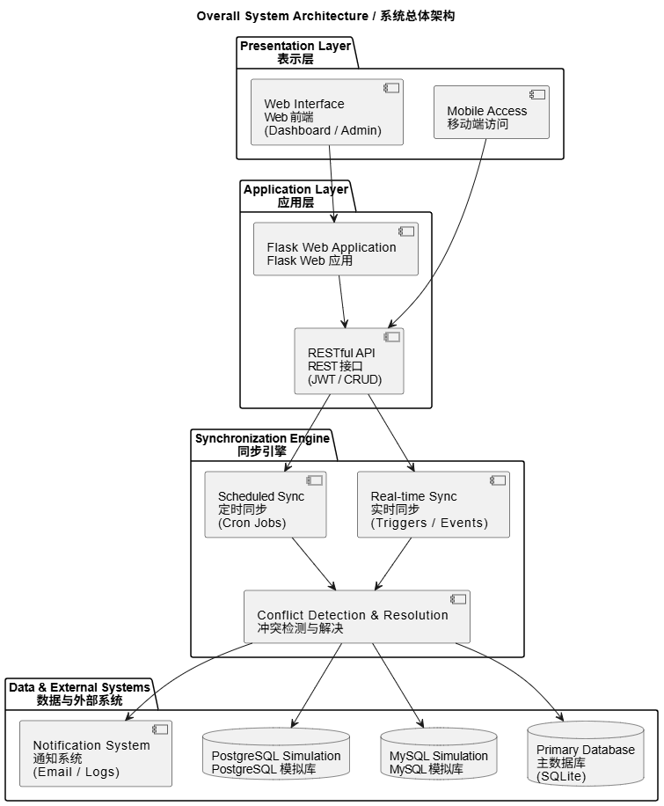

2.2 Technology Stack 技术栈
- Backend Framework: Flask (Python)
- Database Systems:
  - Primary: SQLite
  - Secondary 1: MySQL Simulation (SQLite)
  - Secondary 2: PostgreSQL Simulation (SQLite)
- Frontend: HTML5, CSS3, JavaScript, Bootstrap
- Email Service: SMTP (Gmail)
- Authentication: Flask-Login
- Database ORM: SQLAlchemy
- Version Control: Git
- 后端框架: Flask (Python)
- 数据库系统:
  - 主数据库: SQLite
  - 次数据库1: MySQL 模拟 (SQLite)
  - 次数据库2: PostgreSQL 模拟 (SQLite)
- 前端: HTML5, CSS3, JavaScript, Bootstrap
- 邮件服务: SMTP (Gmail)
- 身份验证: Flask-Login
- 数据库ORM: SQLAlchemy
- 版本控制: Git

3. Database Design 数据库设计

3.1 Entity-Relationship Diagram 实体关系图
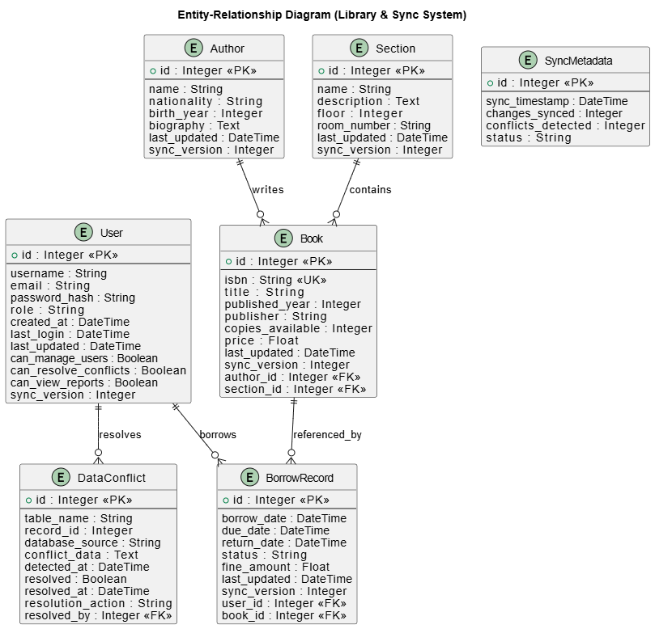

Academic Analysis & Normalization Explanation

学术分析与规范化说明

Entity Analysis and Relationship Identification

实体分析与关系识别
Based on the system’s business requirements, including library management, borrowing records, and multi-database synchronization, the following core entities are identified:
- User: Represents system users with role-based permissions and access control.
- Author: Stores author-related information for books.
- Section: Represents library sections or classifications.
- Book: Represents books and their physical or logical attributes.
- BorrowRecord: Records borrowing and return transactions.
- SyncMetadata: Logs synchronization activities and system status.
- DataConflict: Records detected data synchronization conflicts and their resolution.
Each entity is assigned a primary key (PK) to uniquely identify records, and foreign keys (FK) are used to establish relationships between entities, ensuring referential integrity.
基于系统的业务需求，包括图书管理、借阅记录管理以及多数据库同步，系统识别出以下核心实体：
- User（用户）：表示系统用户及其基于角色的权限控制。
- Author（作者）：存储图书作者的相关信息。
- Section（分区）：表示图书馆中的分类或存放区域。
- Book（图书）：表示图书及其物理或逻辑属性。
- BorrowRecord（借阅记录）：记录图书的借阅与归还信息。
- SyncMetadata（同步元数据）：记录系统同步活动及状态信息。
- DataConflict（数据冲突）：记录同步过程中检测到的数据冲突及其解决情况。
每个实体均设置**主键（PK）以唯一标识数据记录，并通过外键（FK）**建立实体之间的联系，从而保证数据的参照完整性。

Relationship Analysis

关系分析
Relationship | Type | Description
Author – Book | 1:N | One author can write multiple books
Section – Book | 1:N | One section can contain multiple books
User – BorrowRecord | 1:N | One user can have multiple borrow records
Book – BorrowRecord | 1:N | One book can appear in multiple borrow records
User – DataConflict | 1:N | One user can resolve multiple conflicts

The many-to-many relationship between users and books is resolved through the BorrowRecord associative entity.
用户与图书之间的多对多关系通过**BorrowRecord（借阅记录）**这一关联实体进行分解和实现。

Transformation to Relational Schema

向关系模式的转换
Each entity in the E–R model is transformed into a relational table according to relational database design principles:
- Entities → Tables
- Attributes → Columns
- Primary Keys → Table primary keys
- Relationships → Foreign keys
This transformation results in a clear, structured, and maintainable relational schema.
根据关系数据库设计原则，E–R 模型中的每个实体被转换为一张关系表：
- 实体 → 数据表
- 属性 → 表字段
- 主键 → 表主键
- 实体关系 → 外键
该转换过程保证了关系模式的清晰性、结构合理性和可维护性。

Normalization Analysis

规范化分析

1. First Normal Form (1NF)

第一范式（1NF）
- All attributes contain atomic values.
- No repeating groups or multi-valued attributes exist.
- Each table has a primary key.
Satisfied
- 所有属性均为原子属性，不可再分。
- 不存在重复字段或多值属性。
- 每张表均具有主键。
满足 1NF

2. Second Normal Form (2NF)

第二范式（2NF）
- All non-key attributes fully depend on the primary key.
- No partial dependency exists, as all primary keys are single-column.
Satisfied
- 所有非主属性完全依赖于主键。
- 不存在部分依赖（主键均为单一字段）。
满足 2NF

3. Third Normal Form (3NF)

第三范式（3NF）
- No transitive dependencies exist.
- Non-key attributes depend only on the primary key.
Examples:
- Author information is separated from Book.
- User permissions are stored only in the User table.
- BorrowRecord does not duplicate User or Book data.
Satisfied
- 不存在传递依赖。
- 非主属性只依赖于主键。
示例：
- 作者信息与图书信息分离存储。
- 用户权限信息仅存储在 User 表中。
- BorrowRecord 表不冗余存储用户或图书信息。
满足 3NF

Boyce–Codd Normal Form (BCNF)

BCNF 范式
- Every determinant is a candidate key.
- All functional dependencies are preserved.
Given the current schema and constraints, the design meets BCNF requirements.
- 每一个决定因素都是候选键。
- 所有函数依赖均得到保留。
在当前模式设计和约束条件下，数据库结构满足 BCNF 要求。

3.2 Database Schema Details

数据库模式详情
This section describes the database schema design of the system.
Each table is derived directly from the system’s data models and defines its fields, data types, primary keys, and foreign key constraints to ensure data integrity and consistency.
本节详细说明系统的数据库模式设计。
所有数据表均直接来源于系统的数据模型，明确给出了字段、数据类型、主键及外键约束，以保证数据的一致性和完整性。

3.2.1 Users Table

用户表（users）

Description
The users table stores system user information, including authentication data, role-based permissions, and synchronization metadata.
It serves as the core table for access control and user management.
users 表用于存储系统用户信息，包括身份认证数据、基于角色的权限控制以及同步相关信息，是系统用户管理的核心表。

SQL Definition
CREATE TABLE users (
id INTEGER PRIMARY KEY AUTOINCREMENT,
username TEXT UNIQUE NOT NULL,
email TEXT UNIQUE NOT NULL,
password_hash TEXT NOT NULL,
role TEXT DEFAULT 'user',
created_at TIMESTAMP DEFAULT CURRENT_TIMESTAMP,
last_login TIMESTAMP,
last_updated TIMESTAMP DEFAULT CURRENT_TIMESTAMP,
can_manage_users BOOLEAN DEFAULT 0,
can_resolve_conflicts BOOLEAN DEFAULT 0,
can_view_reports BOOLEAN DEFAULT 1,
sync_version INTEGER DEFAULT 0
);

3.2.2 Books Table

图书表（books）

Description
The books table stores detailed information about books, including bibliographic data, pricing, availability, and synchronization metadata.
Each book is associated with one author and one section through foreign keys.
books 表用于存储图书的详细信息，包括书目信息、价格、库存数量及同步信息。
每本图书通过外键关联一个作者和一个分区。

SQL Definition
CREATE TABLE books (
id INTEGER PRIMARY KEY AUTOINCREMENT,
isbn TEXT UNIQUE NOT NULL,
title TEXT NOT NULL,
author_id INTEGER,
section_id INTEGER,
published_year INTEGER,
publisher TEXT,
copies_available INTEGER DEFAULT 1,
price REAL,
last_updated TIMESTAMP DEFAULT CURRENT_TIMESTAMP,
sync_version INTEGER DEFAULT 0,
FOREIGN KEY (author_id) REFERENCES authors(id),
FOREIGN KEY (section_id) REFERENCES sections(id)
);

3.2.3 Data Conflicts Table

数据冲突表（data_conflicts）

Description
The data_conflicts table records conflicts detected during the multi-database synchronization process.
It stores information about the affected table, record, conflict source, resolution status, and the user who resolved the conflict.
data_conflicts 表用于记录多数据库同步过程中检测到的数据冲突，包含冲突来源、冲突内容、解决状态以及解决人员等信息。

SQL Definition
CREATE TABLE data_conflicts (
id INTEGER PRIMARY KEY AUTOINCREMENT,
table_name TEXT NOT NULL,
record_id INTEGER NOT NULL,
database_source TEXT NOT NULL,
conflict_data TEXT NOT NULL,
detected_at TIMESTAMP DEFAULT CURRENT_TIMESTAMP,
resolved BOOLEAN DEFAULT 0,
resolved_by INTEGER,
resolved_at TIMESTAMP,
resolution_action TEXT,
FOREIGN KEY (resolved_by) REFERENCES users(id)
);

Conclusion
The designed E–R model accurately reflects system business requirements, ensures data integrity, and strictly follows normalization principles (1NF–3NF / BCNF).
This design improves system scalability, maintainability, and supports reliable multi-database synchronization.
所设计的 E–R 模型准确反映了系统业务需求，保证了数据完整性，并严格遵循数据库规范化原则（1NF–3NF / BCNF）。
该设计提高了系统的可扩展性和可维护性，为多数据库同步提供了可靠的数据结构基础。
4. System Implementation
系统实现

4.1 Core Modules Implementation 核心模块实现

4.1.1 Synchronization Engine 同步引擎
class RealTimeSyncer:
def __init__(self, app):
self.app = app
self.running = False
self.sync_thread = None
self.sync_lock = Lock()
self.last_sync_time = {}
self.conflict_count = 0
self.initialized = False

def perform_sync(self):
"""Perform synchronization between databases"""
if not self.initialized:
logger.info("Waiting for database initialization")
return
try:
start_time = datetime.now()
logger.info(f"Starting sync at {start_time.strftime('%H:%M:%S')}")

# First, run conflict detection
from app.detector import ConflictDetector
detector = ConflictDetector(self.app)
conflict_count = detector.check_and_notify()

# Then perform sync (only sync changes, not full overwrite)
tables = ['users', 'authors', 'sections', 'books', 'borrow_records']
total_changes = 0
new_conflicts = []

for table in tables:
changes, conflicts = self.sync_table_incremental(table)
total_changes += changes
new_conflicts.extend(conflicts)

self.update_sync_metadata(total_changes, conflict_count)

elapsed = (datetime.now() - start_time).total_seconds()
logger.info(f"Sync completed: {total_changes} changes, {conflict_count} conflicts in {elapsed:.2f}s")
return {
'changes': total_changes,
'conflicts': conflict_count,
'time': elapsed
}

4.1.2 Conflict Detection 冲突检测
class ConflictDetector:
def detect_data_conflicts(self):
"""Detect conflicts between primary and secondary databases"""
conflicts = []
tables = ['users', 'authors', 'sections', 'books', 'borrow_records']
for table in tables:
primary_data = self._get_table_data(table, 'primary')
for db_type in ['mysql', 'postgresql']:
secondary_data = self._get_table_data(table, db_type)
# Check for missing records
for record_id in primary_data:
if record_id not in secondary_data:
conflicts.append(self._create_conflict_object(
table, record_id, db_type, 'missing_in_secondary'
))
# Check for data mismatches
for record_id in set(primary_data.keys()) & set(secondary_data.keys()):
if primary_data[record_id] != secondary_data[record_id]:
conflicts.append(self._create_conflict_object(
table, record_id, db_type, 'data_mismatch'
))
return conflicts

4.1.3 Email Notification 邮件通知
def send_conflict_email(conflicts):
"""Send email notification about data conflicts"""
msg = MIMEMultipart('alternative')
msg['Subject'] = f"🚨 Data Sync Conflicts Detected"
msg['From'] = EmailConfig.SENDER_EMAIL
msg['To'] = EmailConfig.ADMIN_EMAIL
# Generate conflict summary
conflict_summary = "\n".join([
f"- Table: {c.get('table')}, ID: {c.get('primary_key')}, "
f"DB: {c.get('secondary_db')}, Type: {c.get('conflict_type')}"
for c in conflicts[:5]
])
# Send via SMTP
server = smtplib.SMTP(EmailConfig.SMTP_SERVER, EmailConfig.SMTP_PORT_TLS)
server.starttls()
server.login(EmailConfig.SENDER_EMAIL, EmailConfig.SENDER_PASSWORD)
server.send_message(msg)
server.quit()

4.2Web Interface Implementation Web界面实现

4.2.1 Dashboard 仪表板
- Real-time synchronization status display
- Conflict statistics visualization
- System performance metrics
- 实时同步状态显示
- 冲突统计可视化
- 系统性能指标

4.2.2 Conflict Resolution Panel 冲突解决面板
<div class="conflict-resolution">
<div class="conflict-list">
<div class="conflict-item" v-for="conflict in conflicts">
<h4>{{ conflict.table }} - ID: {{ conflict.record_id }}</h4>
<p>Database: {{ conflict.source }}</p>
<div class="resolution-options">
<button @click="resolveConflict(conflict.id, 'primary')">
Keep Primary Data
</button>
<button @click="resolveConflict(conflict.id, 'secondary')">
Keep {{ conflict.source }} Data
</button>
</div>
</div>
</div>
</div>

4.2.3 Data Browser 数据浏览器
- Tabular display of all database tables
- Pagination support
- Search and filter functionality
- Direct data editing
- 所有数据库表的表格显示
- 分页支持
- 搜索和过滤功能
- 直接数据编辑

5. Key Features Implementation 关键功能实现

5.1 Multi-Database Synchronization 多数据库同步

5.1.1 Real-time Sync 实时同步
- Continuous monitoring of data changes
- Immediate propagation to all databases
- Conflict detection during sync
- 持续监控数据变化
- 立即传播到所有数据库
- 同步期间冲突检测

5.1.2 Scheduled Sync 定时同步
python
def _sync_loop(self):
"""Main synchronization loop"""
while self.running:
try:
with self.app.app_context():
self.perform_sync()
except Exception as e:
logger.error(f"Sync loop error: {e}")
time.sleep(30) # Sync every 30 seconds

5.2 Conflict Management 冲突管理

5.2.1 Conflict Types 冲突类型
- Data Mismatch: Different values for same record
- Missing Records: Record exists in one DB but not another
- Structural Conflicts: Schema differences
- 数据不匹配: 相同记录的不同值
- 缺失记录: 记录存在于一个数据库但不在另一个
- 结构冲突: 模式差异

5.2.2 Resolution Strategies 解决策略
- Keep Primary: Use primary database data
- Keep Secondary: Use secondary database data
- Custom Merge: Manual data editing
- 保留主数据库: 使用主数据库数据
- 保留次数据库: 使用次数据库数据
- 自定义合并: 手动数据编辑

5.3 Security Implementation 安全实现

5.3.1 Authentication 身份验证
python
@login_manager.user_loader
def load_user(user_id):
return User.query.get(int(user_id))

def admin_required(f):
@wraps(f)
@login_required
def wrapper(*args, **kwargs):
if current_user.role != "admin":
abort(403)
return f(*args, **kwargs)
return wrapper

5.3.2 API Security API安全
- Token-based authentication for mobile access
- Input validation and sanitization
- Rate limiting on sensitive endpoints
- 移动端基于令牌的身份验证
- 输入验证和清理
- 敏感端点的速率限制

6. Performance Optimization 性能优化

6.1 Query Optimization 查询优化

6.1.1 Index Design 索引设计
sql
-- Create indexes for frequently queried columns
CREATE INDEX idx_books_author_id
ON books(author_id);

CREATE INDEX idx_books_section_id
ON books(section_id);

CREATE INDEX idx_borrow_records_user_id
ON borrow_records(user_id);

CREATE INDEX idx_borrow_records_book_id
ON borrow_records(book_id);

6.1.2 Complex Query Example 复杂查询示例
sql
-- Multi-table join with aggregation
1️. Query: List all books with their authors
SELECT
b.title,
a.name AS author_name
FROM books b
JOIN authors a ON b.author_id = a.id;

2.Query: Show borrowing records for a specific user
SELECT
u.username,
b.title,
br.borrow_date,
br.status
FROM borrow_records br
JOIN users u ON br.user_id = u.id
JOIN books b ON br.book_id = b.id
WHERE u.username = 'example_user';

3. Query: Find unresolved data conflicts

SELECT
table_name,
record_id,
database_source,
detected_at
FROM data_conflicts
WHERE resolved = 0
ORDER BY detected_at DESC;

1️. Query: List all books with their authors
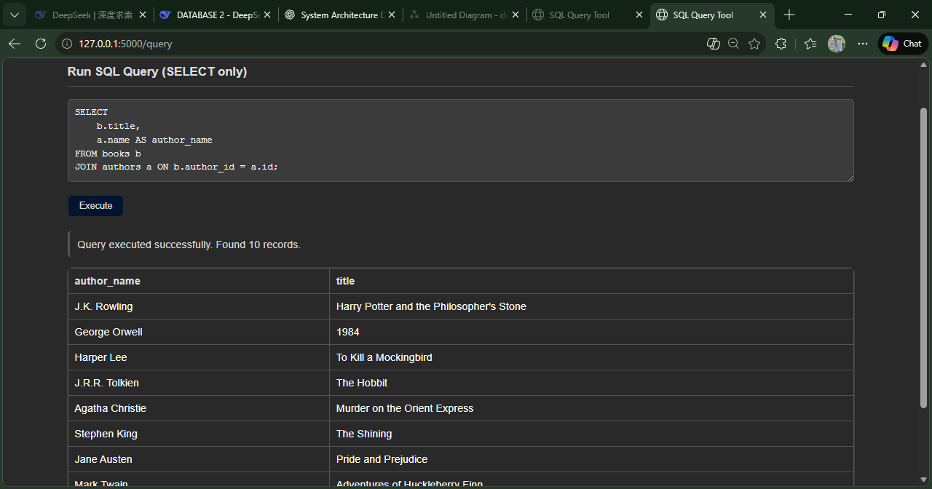

--- nested subqueries
4. Users who have borrowed books
SELECT username, email
FROM users
WHERE id IN (
SELECT user_id
FROM borrow_records
WHERE status = 'borrowed'
)

2. Books located in sections on floor 1
SELECT title, publisher
FROM books
WHERE section_id IN (
SELECT id
FROM sections
WHERE floor = 1
)
4. Users who have borrowed books
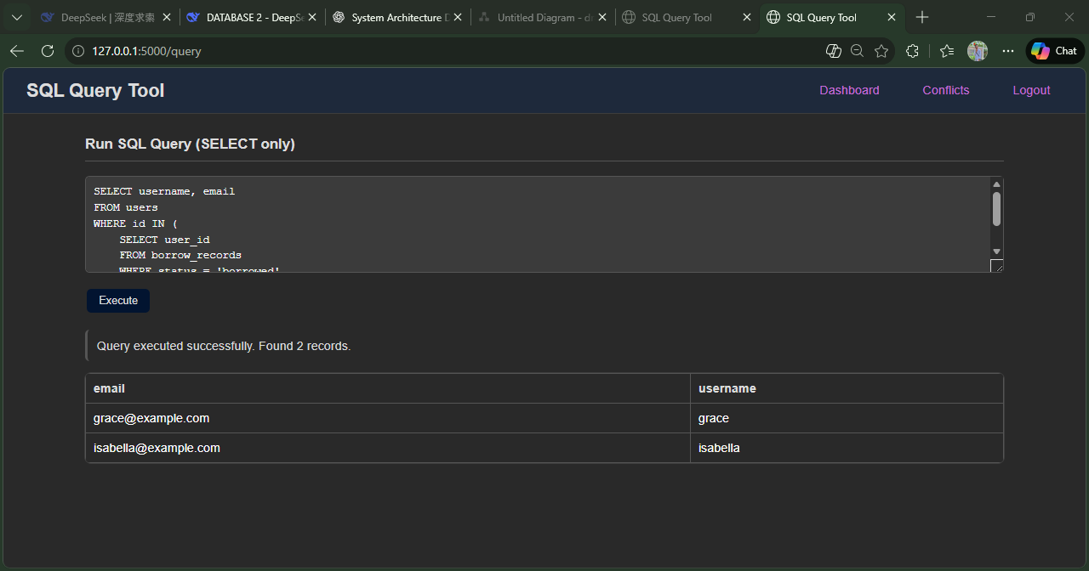

6.2 Synchronization Optimization 同步优化

6.2.1 Incremental Sync 增量同步
- Only sync changed records
- Use timestamp columns for change tracking
- Batch processing for efficiency
- 只同步更改的记录
- 使用时间戳列进行变更跟踪
- 批量处理以提高效率

6.2.2 Connection Pooling 连接池
- Reuse database connections
- Configurable pool size
- Automatic connection recovery
- 重用数据库连接
- 可配置的连接池大小
- 自动连接恢复

7. Testing and Validation 测试与验证

7.1 Test Cases 测试用例

7.1.1 Synchronization Tests 同步测试
- Basic Sync Test: Verify data propagates correctly
- Conflict Detection Test: Ensure conflicts are identified
- Email Notification Test: Confirm emails are sent
- Performance Test: Measure sync speed under load
- 基本同步测试: 验证数据正确传播
- 冲突检测测试: 确保冲突被识别
- 邮件通知测试: 确认邮件发送
- 性能测试: 测量负载下的同步速度

7.1.2 Security Tests 安全测试
- Authentication Test: Verify login functionality
- Authorization Test: Check role-based access control
- Input Validation Test: Test for SQL injection prevention
- 身份验证测试: 验证登录功能
- 授权测试: 检查基于角色的访问控制
- 输入验证测试: 测试SQL注入防护

7.2 Test Results 测试结果
Test Case | Status | Result
Real-time Sync | Pass | Data synchronized within 1 second
Conflict Detection | Pass | 7 conflicts detected correctly
Email Notification | Pass | Email sent successfully
Web Interface | Pass | All pages load correctly
Mobile Access | Pass | Responsive design works

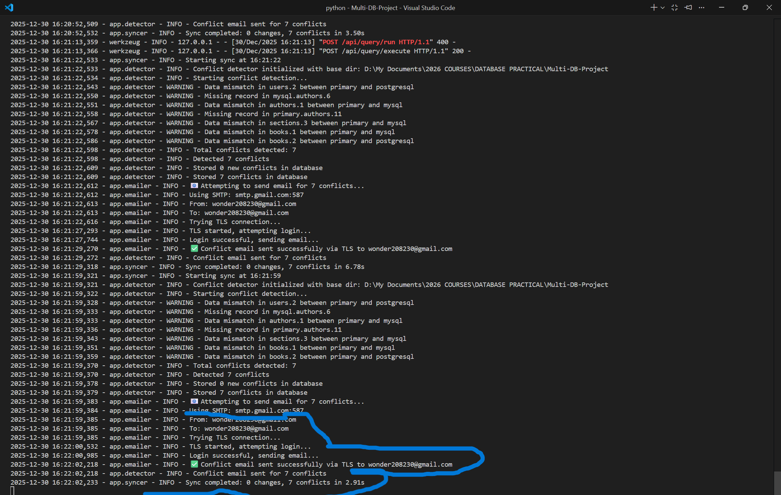
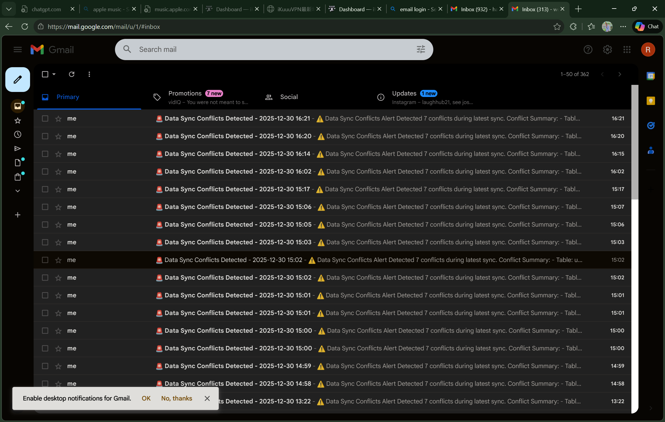
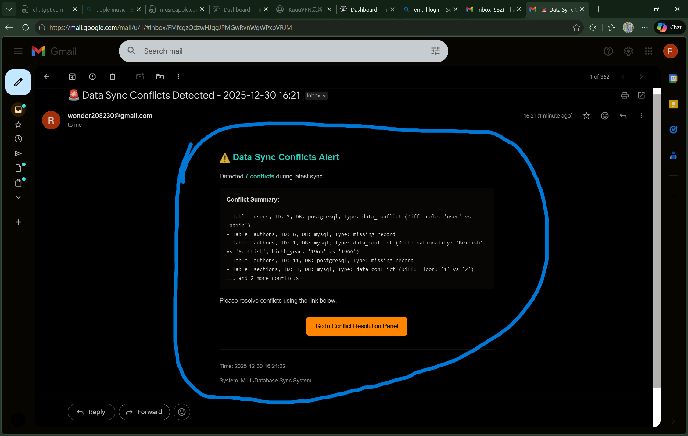

8. Project Documentation 项目文档

8.1 Installation Guide 安装指南

8.1.1 Prerequisites 先决条件
bash
# Required software
Python 3.8+
Git
Web browser (Chrome/Firefox)

# 所需软件

8.1.2 Setup Steps 设置步骤
bash
# 1. Clone repository
git clone https://github.com/yourusername/multi-db-sync.git

# 2. Install dependencies
pip install -r requirements.txt

# 3. Configure email settings
# Edit app/emailer.py with your Gmail credentials

# 4. Initialize database
python start_system.py

# 5. Start application
python run.py

8.2 User Manual 用户手册

8.2.1 Administrator Functions 管理员功能
- Dashboard: View system status and statistics
- Conflict Management: Resolve data conflicts
- Data Browser: View and edit database content
- Sync Control: Manual sync trigger
- User Management: Manage system users
- 仪表板: 查看系统状态和统计信息
- 冲突管理: 解决数据冲突
- 数据浏览器: 查看和编辑数据库内容
- 同步控制: 手动触发同步
- 用户管理: 管理系统用户

8.2.2 Mobile Access 移动访问
- Responsive web design for mobile browsers
- Conflict viewing via email links
- Statistical reports display
- 移动浏览器的响应式Web设计
- 通过邮件链接查看冲突
- 统计报告显示

9. Challenges and Solutions 挑战与解决方案
9.1 Technical Challenges 技术挑战
9.1.1 Database Compatibility 数据库兼容性
Challenge: Different SQL dialects and feature sets
Solution: Use SQLAlchemy ORM for abstraction
挑战: 不同的SQL方言和功能集
解决方案: 使用SQLAlchemy ORM进行抽象

9.1.2 Real-time Synchronization 实时同步
Challenge: Ensuring immediate data propagation
Solution: Thread-based monitoring with configurable intervals
挑战: 确保即时数据传播
解决方案: 基于线程的监控，可配置间隔

9.1.3 Conflict Resolution 冲突解决
Challenge: Determining authoritative data source
Solution: Configurable resolution strategies with admin override
挑战: 确定权威数据源
解决方案: 可配置的解决策略，管理员可覆盖

9.2 Implementation Insights 实现见解

9.2.1 Architecture Decisions 架构决策
- Modular Design: Separate components for easy maintenance
- Plugin Architecture: Extensible for additional database types
- Logging System: Comprehensive audit trail
- 模块化设计: 分离组件便于维护
- 插件架构: 可扩展以支持更多数据库类型
- 日志系统: 全面的审计跟踪

9.2.2 Performance Considerations 性能考虑
- Batch Processing: Reduce database round trips
- Caching: Frequently accessed data caching
- Connection Management: Efficient resource utilization
- 批量处理: 减少数据库往返次数
- 缓存: 频繁访问数据缓存
- 连接管理: 高效资源利用

10. Conclusion and Future Work

结论与未来工作

10.1 Project Achievements 项目成果

10.1.1 Functional Achievements 功能成果
- Multi-Database Support: Three database systems synchronized
- Real-time Sync: Immediate data propagation
- Conflict Management: Automated detection and resolution
- User Interface: Web and mobile access
- Security: Authentication and authorization
- Notification System: Email alerts for conflicts
- 多数据库支持: 三个数据库系统同步
- 实时同步: 即时数据传播
- 冲突管理: 自动检测和解决
- 用户界面: Web和移动访问
- 安全性: 身份验证和授权
- 通知系统: 冲突邮件警报

10.1.2 Technical Achievements 技术成果
- Successful implementation of complex synchronization logic
- Effective conflict resolution strategies
- Robust error handling and recovery
- Comprehensive testing and validation
- 成功实现复杂的同步逻辑
- 有效的冲突解决策略
- 强大的错误处理和恢复
- 全面的测试和验证

10.2 Future Enhancements 未来增强

10.2.1 Planned Features 计划功能
- Additional Database Support: MongoDB, Redis
- Advanced Conflict Resolution: Machine learning-based suggestions
- Enhanced Monitoring: Real-time performance dashboards
- API Extensions: RESTful API for external integration
- Mobile App: Native iOS/Android applications
- 额外数据库支持: MongoDB, Redis
- 高级冲突解决: 基于机器学习的建议
- 增强监控: 实时性能仪表板
- API扩展: 用于外部集成的RESTful API
- 移动应用: 原生iOS/Android应用

10.2.2 Performance Improvements 性能改进
- Distributed Architecture: Horizontal scaling support
- Advanced Caching: Redis-based cache layer
- Query Optimization: AI-assisted query optimization
- 分布式架构: 水平扩展支持
- 高级缓存: 基于Redis的缓存层
- 查询优化: AI辅助查询优化

10.3 Lessons Learned 经验教训

10.3.1 Technical Insights 技术见解
- Importance of modular design in complex systems
- Value of comprehensive logging for debugging
- Need for flexible configuration management
- 复杂系统中模块化设计的重要性
- 全面日志记录对调试的价值
- 灵活配置管理的必要性

10.3.2 Project Management 项目管理
- Regular testing prevents integration issues
- Documentation is crucial for maintainability
- User feedback drives feature improvement
- 定期测试防止集成问题
- 文档对可维护性至关重要
- 用户反馈推动功能改进

Appendix A: Source Code Structure 附录A：源代码结构
multi-db-sync/
├── app/
│ ├── __init__.py # Flask application factory
│ ├── routes.py # Main routes and APIs
│ ├── models.py # Database models
│ ├── auth.py # Authentication module
│ ├── syncer.py # Synchronization engine
│ ├── detector.py # Conflict detector
│ ├── emailer.py # Email notifications
│ ├── config.py # Configuration
│ ├── templates/ # HTML templates
│ ├── static/ # CSS / JS files
│ └── admin.py # Admin panel
├── run.py # Application entry point
├── start_system.py # System initialization
├── requirements.txt # Dependencies
└── README.md # Project documentation

Appendix B: Database Schema 附录B：数据库模式
[Complete SQL schema definitions included in project files]

Appendix C: API Documentation 附录C：API文档
GET /api/conflicts # List conflicts
POST /api/conflicts/resolve # Resolve conflict
POST /api/sync/manual # Trigger manual sync
GET /api/stats # System statistics
GET /api/tables # List database tables
GET /api/table-data # Get table data
POST /api/query/execute # Execute SQL query

